PPTController useage Content

For Wifi mode Pre-condition 1

For Bluetooth mode Pre-condition. 3

For HotSpot Pre-condition 6

# Three kinds of connection mode for PPTController.

**1. Wifi mode**

When your computer and phone are under same wifi environment. Your phone will be able to detect all the computers which installed the PPTControllerHost. Click the Connect button in your PPTController to establish a connection between your computer and Phone.Then you will able to control your ppt through your Windows phone.

**2. Bluetooth mode**

When your computer support Bluetooth feature or installed a bluetooth plug-in. You need to create a Receive COM port for receive the commands send from your phone. Enable the bluetooth auto detection both on your computer and phone. Paired them in your PPTController.

**3. HotSpot**

HotSpot is for the case which didn't have a Wifi connection nor Bluetooth. It will help you build your own wifi base on your computer. Connect your computer base on the created wifi just like Wifi mode. This feature is supported by most of laptops and windows OS version >= win7.

# For Wifi mode Pre-condition

1. Need to setup the PPTController listener mode to Wifi. This is by default while opened PPTControllerHost.

**For the computers auto detect feature, please notice here,**

If your computers exist muti IP address like below, this feature will probably disabled. In this case you need to fill your computer’s IP address manually in PPTController.

#### Muti IP Sample

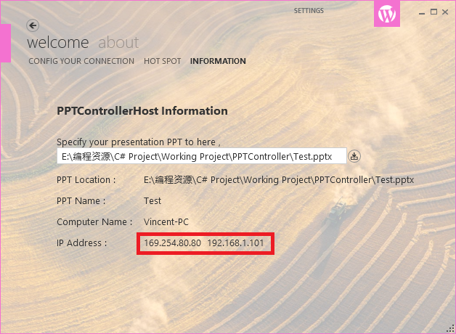

In this case you need to try both IP address “196.254.80.80” and “192.168.1.101”, PPTController will give you connect result if you had correctly connected.

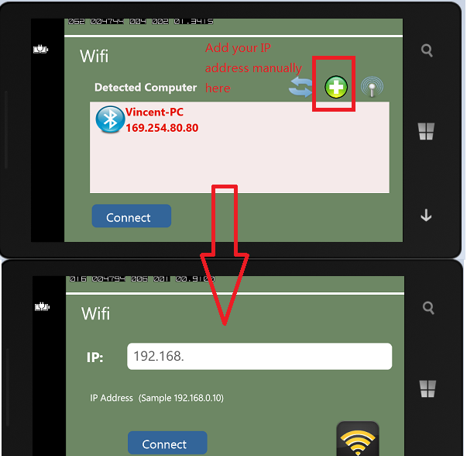

#### Simple IP Sample,

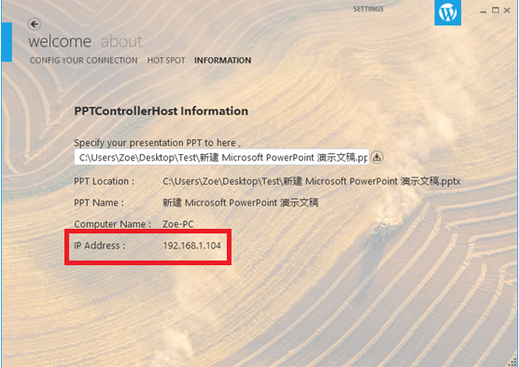

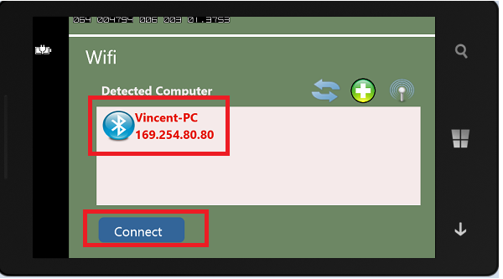

Here you simply need to select your computer and click connect.

# For Bluetooth mode Pre-condition.

1. Need to setup the PPTController listener mode to Bluetooth.
2. Your Bluetooth was enable auto detect.
3. The drive for Bluetooth had installed correctly.

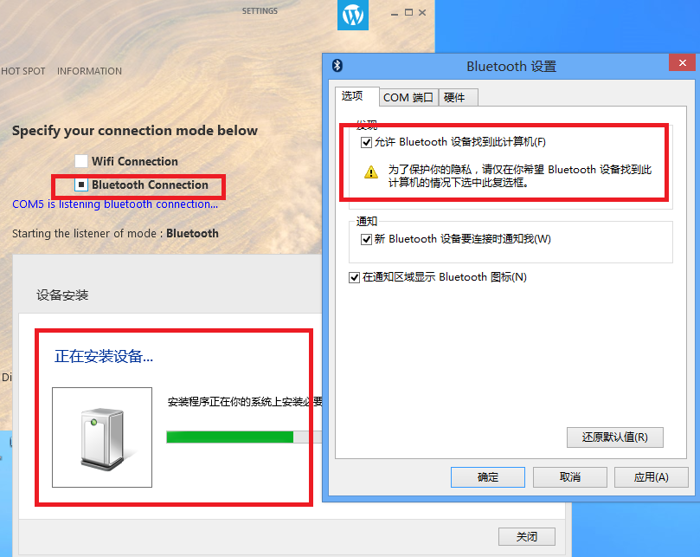

1. You need to create an Import COM port when you first use your Bluetooth.

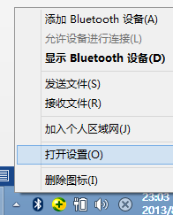

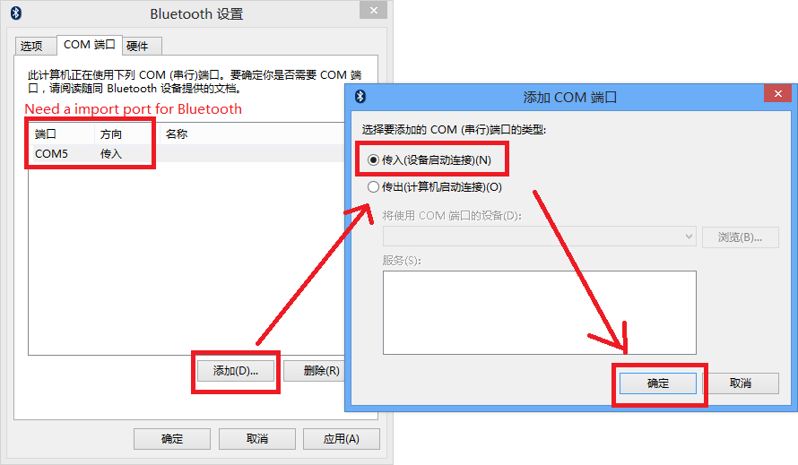

You windows will show the connected Windows phone.

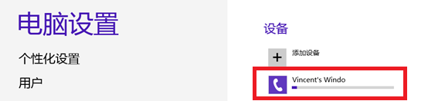

After install finished,

Pared your computer with your windows phone and click connect,

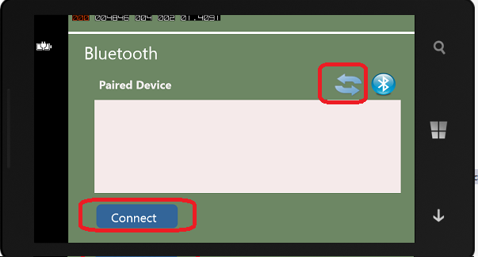

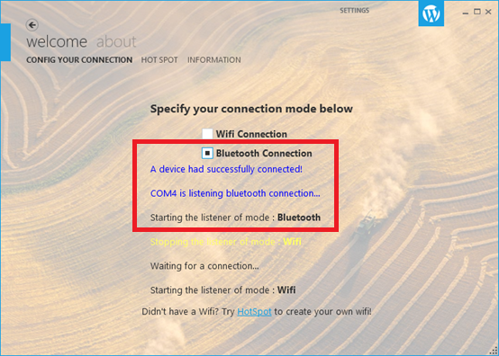

# For HotSpot Pre-condition

1. Start your PPTControllerHost by Admin!
2. Need to setup the PPTController listener mode to Wifi.

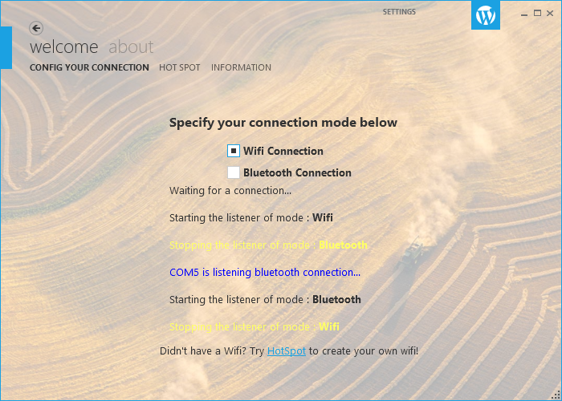

1. Start your HotSpot, Default IP will be **192.168.173.1**

